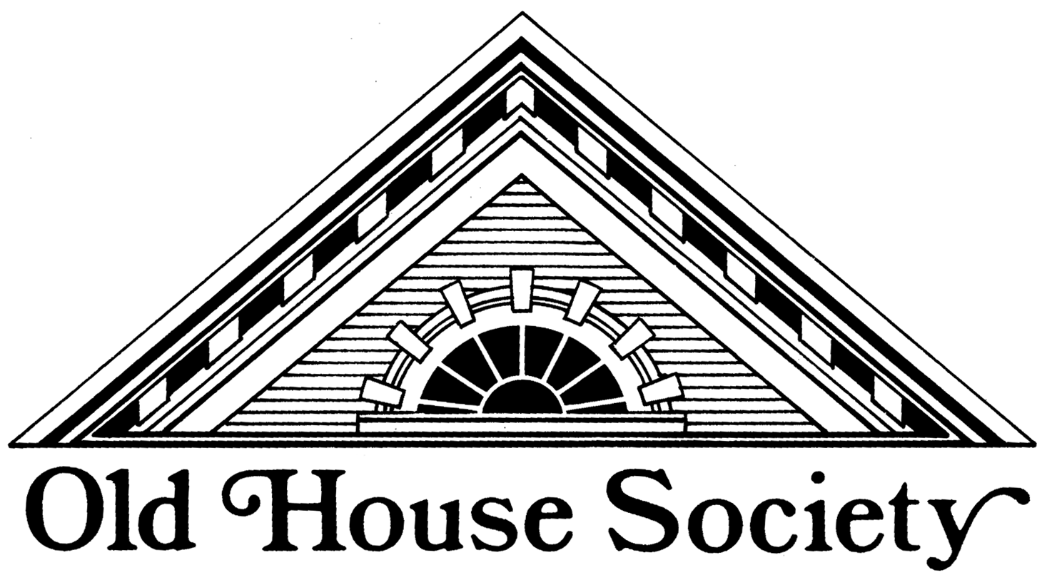
www.oldhousesociety.org

Our Mission Promote and preserve buildings, landscapes, and neighborhoods

more than 50 years old, and the communities and heritage they foster.

MEMBERSHIP FORM

Just a few of your Membership Benefits: Enjoy a 10% discount at our Architectural Salvage Warehouse
Receive invitations to Special Events (please provide your email address below)
Meet People with Similar Interests
Promote Local History and Traditional Neighborhoods

Your financial support creates an opportunity to build better communities. Please renew your Membership today!
Also, check out our Facebook page to see new inventory and other communications.

Member Level
$ 25 Student & Retiree
$ 35 Individual
$ 50 Family

The Old House Society is an IRC Section 501(c)(3) not-for-profit organization.

Keep top portion for your records
_______________________________________________________________________________________________________________________________________________________________________________________________________
detach here detach here

Old House Society

Membership Dues

Name __________________________________________________ Date _________________________________

Address ___________________________________________________ Phone #______________________________

City __________________________________ State ____________ Zip Code ___________________________

Email ___________________________________
(required please, so we can send you updates) Membership Dues $ ________

Additional Donation (optional) $ ________

Total Enclosed $ ________

Make check payable to Old House Society (cancelled check is your receipt)

or Charge my Visa / MasterCard #__________________________________________ expires ___________
(circle one) (16 digit number) (mo/yr)

Mail completed form (and check if applicable) to: Old House Society
P.O. Box 581
Bloomington, IL 61702

